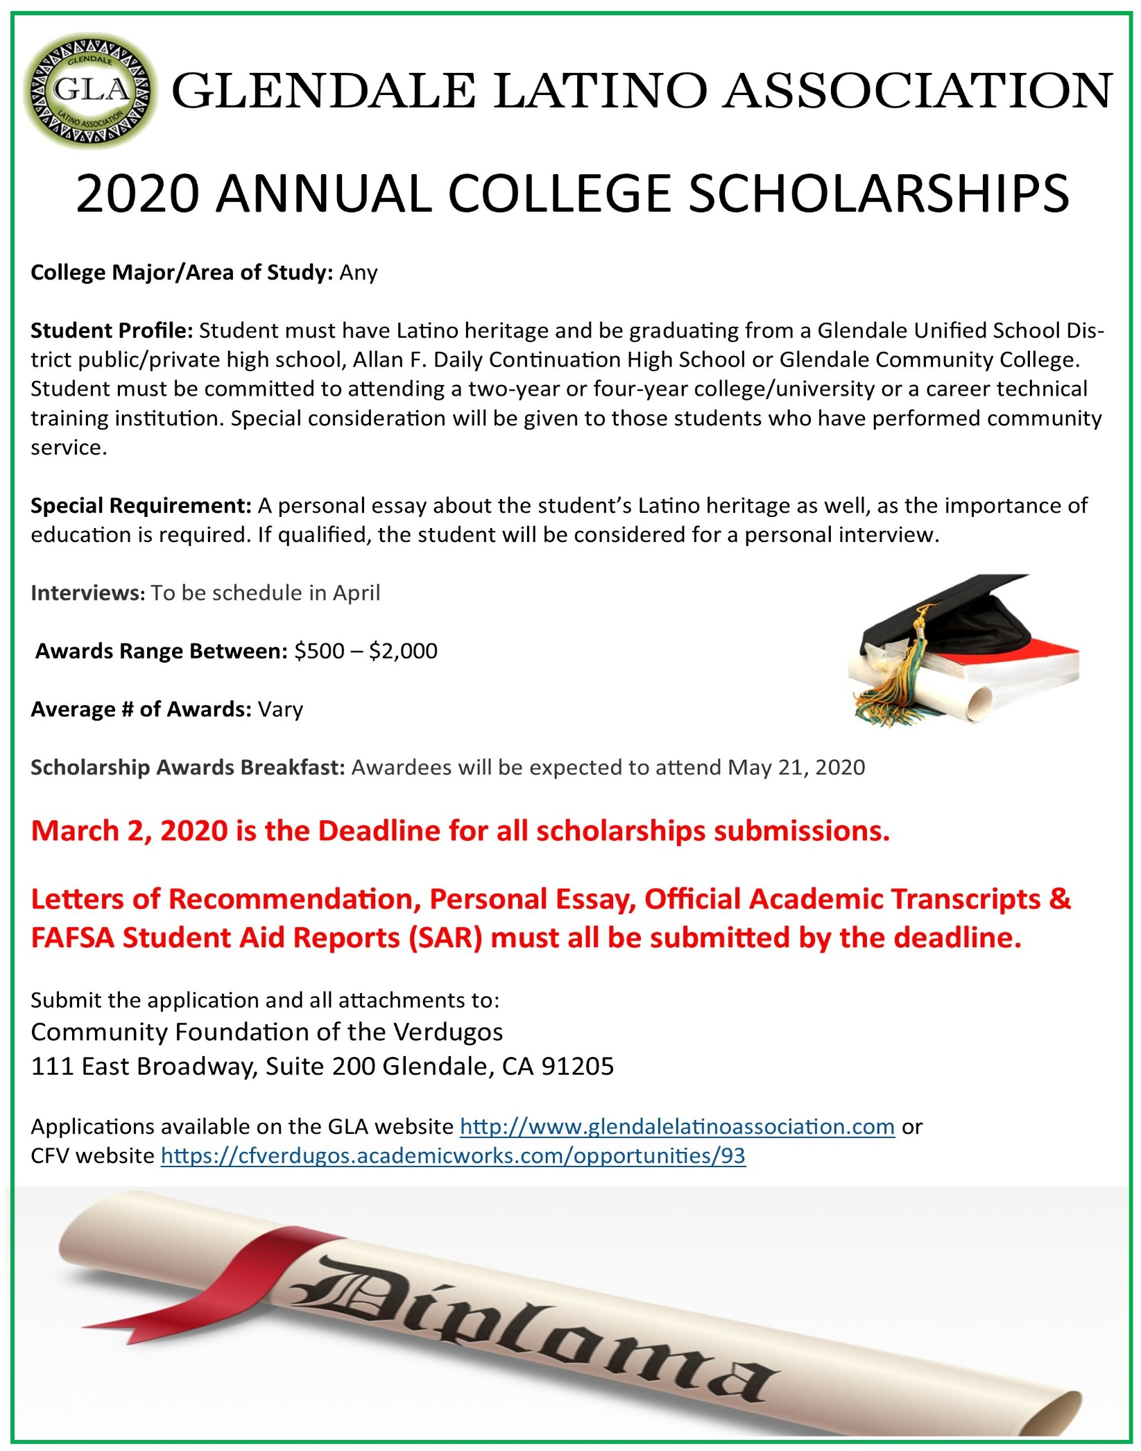

2024

Annual College Scholarship Program

**College Major/Area of Study: Any**

**April 30th, 2024 is the Deadline for next year’s scholarships submissions.**

**Letters of Recommendation, Personal Essay, Official Academic Transcripts and GPA.**

**Applications available on our website:** www.owenwhitfield.org

**Submit the application and all attachments to:** The Whitfield Historical Foundation 8311 Jefferson Ave. St. Louis, Mo. 63114



**Interviews:** To be scheduled in May

**Awards Range Between:** $500.00 - $2,000.00

**Average # of Awards:** Vary

**Scholarship Awards Breakfast:** Awardees will be expected to attend

**Special Requirement:** A personal essay about the student’s heritage, as well as the importance of education is required. If qualified, the student will be considered for a personal interview.

**Student Profile:** Student must have minority heritage and be graduating from any St. Louis City or County school. Students must be committed to attending a two-year or four-year college/university or a career technical training institution. Special consideration will be given to those students who have performed community service.